Analysis of the Value of Family & Consumer Sciences Extension in the
North Central Region

Prepared by: Battelle
505 King Avenue
Columbus, Ohio 43201

Submitted to:
Directors of Cooperative Extension, North Central Region

June 18, 2015

Table of Contents
Executive Summary ................................................................................................................................ ES-1
Section I. Introduction 1
Section II. Food, Nutrition & Health 12
- Healthy Eating, Physical Activity & Healthy Lifestyles 13
- Food Security 27
- Food Safety 34
- Chronic Disease Prevention & Management 37
- Health Literacy & Health Insurance Literacy 43
Section III. Family & Human Development 52
- Child Development 52
- Early Childhood Education 56
- Parent Education 60
- Relationships & Family Dynamics 63
- Adult Development & Aging 67
Section IV. Family Resource Management 75
- Financial Literacy 76
- Advanced Financial Management 80
Section V. Funding of FCS Extension 85
Appendices 96
Appendix A: North Central Region Land-Grant Universities, Extension Units & FCS Units 96
Appendix B: Timeline in the Evolution of Family & Consumer Sciences in Land-Grant Universities 97
Appendix C: Peer-Reviewed Research by North Central Region FCS Extension Faculty 98

This report was sponsored by Cooperative Extension at:
University of Illinois Purdue University Iowa State University
Kansas State University Michigan State University University of Minnesota University of Missouri University of Nebraska - Lincoln North Dakota State University The Ohio State University
South Dakota State University University of Wisconsin System

Special thanks are owed to the team of Family & Consumer Sciences Extension professionals in the North Central Region who worked with Battelle on this report. The committee, consisting of program leaders Karen Bruns, Deb Gebeke, and Paula Peters, spent countless hours guiding the effort. In addition, program leaders (or acting program leaders) at all of the member universities gathered and interpreted large amounts of information concerning their programming, budgets, organizational structure, and more. They are: Angie Abbott,
Linda Boeckner, Laurie Boyce, Jo Britt-Rankin, Dawn Contreras, Jennifer McCaffrey, Trish Olson, Deb Sellers, and Suzanne Stluka.
Battelle would also like to thank Robin Shepard, Executive Director for the North Central Cooperative Extension Association, and Tony Zech, the state agency SNAP-Ed liaison for the State of Wisconsin, for their insights and role in gathering information for use in this report.

List of Tables
Table 1: The Domains of Family Practice, adapted to Family & Consumer Sciences Extension subject matter 5
Table 2: North Central Region Extension and Family & Consumer Sciences unit titles 9
Table 3: Key characteristics of the EFNEP and SNAP-Ed programs nationally, 2012 18
Table 4: SNAP-Ed cost and reach – Extension and other providers nationally, 2010 , 19
Table 5: Key Outcomes as a result of Extension-provided SNAP-Ed and EFNEP, 20
Table 6: Estimated financial impact of EFNEP education in the North Central Region, 2014 21
Table 7: Examples of valuable FCS Extension programs in nutrition 23
Table 8: Examples of valuable FCS Extension programs in physical activity and healthy lifestyles 27
Table 9: Examples of valuable FCS Extension programs in food security and local food systems 34
Table 10: Examples of valuable FCS Extension programs in food safety 37
Table 11: Examples of valuable FCS Extension programs in chronic disease prevention and management 43
Table 12: Examples of valuable FCS Extension programs in health literacy and health insurance literacy 46
Table 13: Survey responses from providers on key childcare strategies from Rock Solid Foundations 55
Table 14: Examples of valuable FCS Extension programs in child development 56
Table 15: Examples of valuable FCS Extension programs in early childhood education 60
Table 16: Examples of valuable FCS Extension programs in parenting 62
Table 17: Examples of valuable FCS Extension programs in relationships and family dynamics 66
Table 18: Examples of valuable FCS Extension programs in adult development and aging 71
Table 19: Examples of valuable FCS Extension programs in financial literacy 80
Table 20: Examples of valuable FCS Extension programs in advanced financial management 83
Table 21: FCS Extension funding by source in the North Central Region, 2014 86
Table 22: EFNEP and SNAP-Ed funding in the North Central Region, 2014 91
List of Figures
Figure 1: Human Ecological System Theory as the basis for Family & Consumer Sciences Extension education 4
Figure 2: Household food insecurity and unemployment in the U.S., 2000–2012 28
Figure 3: Direct face-to-face contacts across the region by subject area, 2014 49
Figure 4: U.S. personal savings rate, 1960–2014 75
Figure 5: Trends in U.S. poverty,1960–2013 75
Figure 6: FCS Extension funding by source in the North Central Region, 2014 86
Figure 7: Smith-Lever funding nationally, 2002–2014 87
Figure 8: SNAP-Ed funding nationally, 2004–2014 92
Figure 9: SNAP-Ed funding and SNAP-participating households nationally, 2004–2013 92
Figure 10: Annual SNAP-Ed funding per SNAP-participating household nationally, 2004–2013 93
Figure 11: EFNEP funding and participants nationally, 2006–2014 94

Executive Summary

While the United States provides its people with many opportunities, and represents the largest and most diverse economy among nations, there is no hiding the fact that it is also a country where tens of millions
of residents face significant problems and challenges. Over 45 million Americans presently live in poverty, and U.S. life expectancy is just 42nd among all nations. Almost 79 million Americans are obese, and more than 117 million residents have one or more chronic health conditions. Over 87 million in the nation are worried about having enough money each month to pay their regular monthly bills, and 17.6
million U.S. households are food insecure. We have the highest incarceration rate of any nation, and, if presented with this report, more than 32 million adult Americans would be unable to read it because they are illiterate.1 We can, and should, do better.
In the U.S., the academic discipline that focuses on a holistic approach for the development of fact-based, research-driven educational programs to improve well-being is Family & Consumer Sciences.

This report provides an overview of the primary disciplinary content within Family & Consumer Sciences, and describes the impact this content has through the delivery of educational programming via the work of Cooperative Extension in the North Central Region. It also discusses

What is Family & Consumer Sciences?
The American Association of Family & Consumer Sciences (AAFCS) describes Family & Consumer Sciences as the :
“…comprehensive body of skills, research, and knowledge that helps people make informed decisions about their well-being, relationships, and resources to achieve optimal quality of life.”
The National Institute of Food and Agriculture (NIFA) describes Family & Consumer Sciences similarly, adding that it is the:
“… integrative, multidisciplinary field of science that studies relationships among humans and their environments to foster quality of life, strengthen communities, and achieve a healthy sustainable world.”
those aspects of Family & Consumer Sciences Extension that make it particularly effective, and that differentiate it from other organizations working to improve the nation’s health and well-being. Key findings, challenges, and opportunities are featured, and selected individual programming impacts highlighted.

While traditional faculty members teach on campus to undergraduate and graduate students, Extension faculty develop programming for the public, prepare county or regional staff to deliver educational programs across the state, and in some states deliver programming themselves. As one director said, “The state is our campus”. The connection to the departments on campus is key to Extension’s mission of providing research-based education. Thus, Extension combines the academic power of campus-based researchers with a robust state-wide delivery system.

Overview
Extension faculty in land-grant university Family & Consumer Sciences Extension are engaged in frontline research and education focused on helping individuals, families, and communities reach their full potential.
Family & Consumer Sciences Extension is a highly pragmatic and proactive discipline focused on tangible results, with an active focus on nutrition, physical activity, health and well-being, human development, and personal financial management.

1 U.S. Census Bureau, www.census.gov/hhes/www/poverty/data/historical/people.html; The World Bank, http://data.worldbank.org/indicator/SP.DYN.LE00.IN/countries?display=default; CDC, Adult Obesity Facts, www.cdc.gov/obesity/data/adult.html; CDC, Chronic Diseases and Health Promotion, www.cdc.gov/chronicdisease/overview/; Gallup poll, www.gallup.com/poll/168626/retirement-remains-americans-top-financial-worry.aspx; USDA ERS, www.ers.usda.gov/publications/err- economic-research-report/err173.aspx; U.S. Department of Education, National Institute of Literacy, 2013

While Family & Consumer Sciences can trace its roots back to the 1800’s, the discipline is as contemporary and relevant now as it has ever been. The modern discipline of Family & Consumer Sciences covers many areas that have been part of the field since its inception, and others which reflect the growing recognition of the importance of social and economic issues to the well-being of individuals, families, and communities. The areas discussed in this report
include:
The Foundation of a Network of Support
Family & Consumer Sciences Extension equips those it educates with the tools, processes, and knowledge required for healthy living. In addition to direct education to individuals and families, education is often provided through a train-the-trainers approach, whereby the research-based solutions of Family & Consumer Sciences Extension are transferred to professionals or volunteers at family serving agencies, non-profit providers, and other organizations that directly interface with the target audiences.
Family & Consumer Sciences Extension thereby fills a critical need in providing curricula, programming materials, and other tools that empower service providers in communities across the nation. Rather than researching or developing their own programs and identifying best practices, they can turn to Family & Consumer Sciences Extension to provide a solid base of well-researched, tested, and proven techniques and educational content.
Family & Consumer Sciences, therefore, can be seen to form the bedrock or foundation that supports the activities of a large network of individual organizations, family serving agencies, educators, and other stakeholders that provide education and support for individuals and their families.
  - Food, Nutrition & Health
  - Family & Human Development
  - Family Resource Management
The American Association of Family & Consumer Sciences defines Family & Consumer Sciences more broadly, to also include
Consumer Issues, Housing & Interior Design, and Textiles & Apparel.2 However, it is not possible to support all of these areas with the available funding, and therefore Family & Consumer
Sciences Extension in the region, and across the country, has focused its resources into the three major areas outlined above.

A majority of the activity in Family & Consumer Sciences Extension depends on public funds — from federal, state, and local governmental agencies — for support. Given this reliance on public funds, the leadership of Family & Consumer Sciences Extension programs across the North Central Region deemed it important to commission an independent evaluation of the discipline within the region, its relevance to contemporary challenges, and the impacts being achieved. With government needing to prioritize its distribution of scarce resources, it is particularly important that key policymakers and decision influencers have the information they need to make informed decisions. Battelle, the world’s largest independent non-profit research organization, was retained by Cooperative Extension at the land-grant universities in the North Central Region to conduct this assessment. These universities are University of Illinois, Purdue University, Iowa State University, Kansas State University, Michigan State University, University of Minnesota, University of Missouri, University of Nebraska-Lincoln, North Dakota State University, The Ohio State University, South Dakota State University, and University of Wisconsin System.

Each state in the region has its own unique title for its Extension activities, and for its Family & Consumer Sciences unit. For simplicity, within this report each state’s Extension unit will be referred to as “Extension”, and each unit that delivers programming in this area will be referred to as Family & Consumer Sciences. Appendix A shows the titles used at each university.

2 American Association of Family & Consumer Sciences, “What is FCS?”, www.aaFamily & Consumer Sciences.org/AboutUs/FCS.asp

Family & Consumer Sciences Extension uses the Human Ecological System Theory3 (Figure ES-1) as the theoretical basis of its work — a theory that explicitly recognizes that individuals develop within the contexts of family, communities, and society, and that their developmental outcomes are influenced through interactions with these various contexts. This paradigm is reflected in the recent expansion of Family & Consumer Sciences Extension activities from basic educational programming directed at individuals and families, to the creation and support of infrastructure within communities to support healthy living. In this context, the word “infrastructure” does not refer to physical structures, but rather to the underlying framework — including the resources, trained personnel, processes, and mindset — needed at a community level to support healthy living. At the highest level in the human ecological system, Family & Consumer Sciences Extension is involved in policy efforts to help create an environment in which healthy living is the accepted societal norm.

Figure ES-1: The Family & Consumer Sciences Human Ecological System Theory4

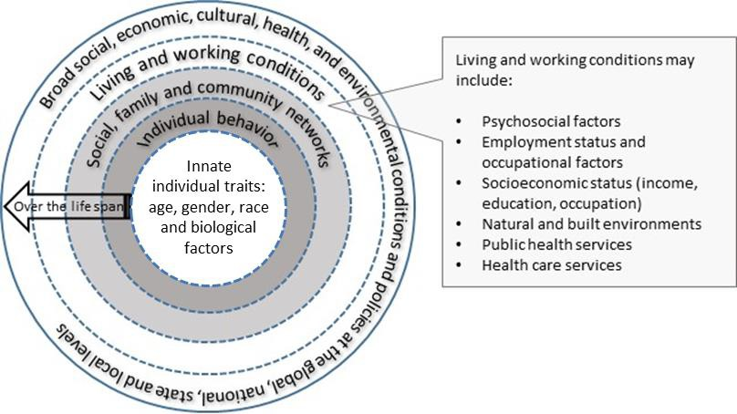

Family & Consumer Sciences Extension crosses all levels of the human ecological system and the lifespan, and has a significant interface with the other areas within Extension at land-grant universities: Agriculture and Natural Resources, Community Development, and 4-H Youth Development.
Professionals in each of the different areas of Extension work synergistically to develop and deliver programming across subject areas and audiences.

Extension differs from social service organizations in that it targets prevention education before significant problems arise or just as difficulties emerge, while social service organizations typically provide intervention services to those who have been clearly identified as having that need. Preventing problems before they happen, through education, is more effective and more economical than intervention or remediation after unhealthy behaviors have become entrenched.

Doing justice to a field as diverse as Family & Consumer Sciences is no easy task, and the reader is encouraged to consult the full report in order to gain a thorough introduction to the content of the discipline. Each section in the report not only describes key disciplinary focus areas, but also provides

3 Myers-Walls J, Ballard S, Darling S, and Myers-Bowman K, 2011. “Reconceptualizing the domain and boundaries of Family Life Education”
Family Relations: Interdisciplinary Journal of Applied Family Studies, 60, pp. 347-372.
4 Bronfenbrenner U, 1979, “The Ecology of Human Development: Experiments by Nature and Design”, Cambridge, MA: Harvard University Press, (ISBN 0-674-22457-4)

examples and case studies of North Central Region Family & Consumer Sciences Extension in addressing associated needs.

Programing and Impacts in Food, Nutrition & Health

Food, Nutrition & Health is the powerhouse of Family & Consumer Sciences Extension, and accounts for nearly 90% of the individuals who are reached through its educational programs across the North Central Region. The principal content of this domain is illustrated in Figure ES-2, showing the six high-level thematic areas of work and key examples of content falling under these themes.

Figure ES-2: Principal areas of activity in Food, Nutrition & Health

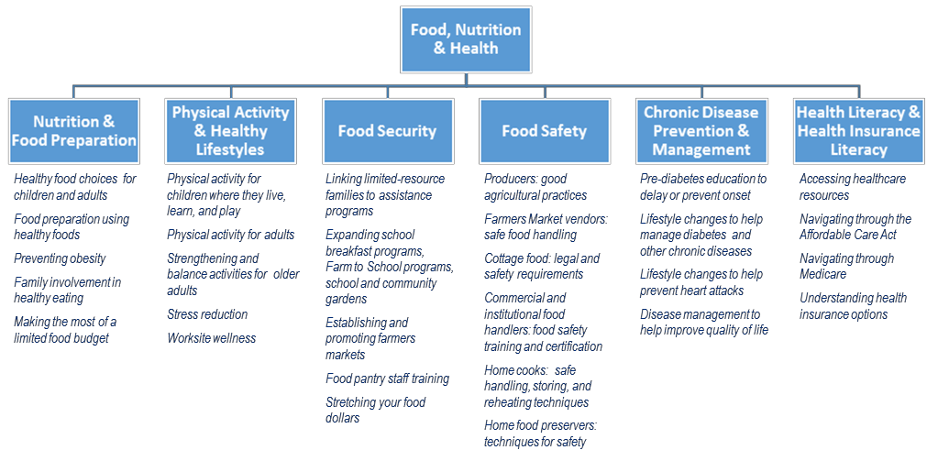

Family & Consumer Sciences Extension works to understand the key social and behavioral factors that impact health, and to give children, youth, and adults skills that contribute to better health across the lifespan. It also works to identify the community and societal factors that facilitate or inhibit healthy nutrition and lifestyle choices, and address these through programs targeted at behavior influencers, through establishing infrastructure that will advance healthy living, and by working at the policy level to help bring about broad changes to promote a healthier society. In this regard, Extension professionals in Food, Nutrition & Health work on major questions and issues such as:
    - What are the underlying causes of unhealthy diet decisions?
    - What tools and information do people need to help them make healthy nutrition decisions?
    - How can children be encouraged to develop healthy eating and physical activity patterns that will persist across their lifespan?
    - What do recipients of food assistance programs need in order for them to make wise food purchase decisions and stretch their food dollars?

- What techniques can food suppliers, handlers, and consumers use to reduce the risk of foodborne illness?
- What actions should individuals take to avoid the development of preventable chronic diseases and the associated physical and cost burdens?
- How can public policy impact access to healthy food and improve food security?
- How can families and individuals best navigate the complex American healthcare system and best make use of its resources to optimize their health?
Family & Consumer Sciences Extension has a long history of helping families make healthy nutritional choices. In the late 1960’s, as part of a national focus on poverty, Extension developed the Expanded Food and Nutrition Education Program (EFNEP), which is still delivered solely by Extension today. This federally funded program is intense in its duration and content, and in the required commitment of its participants. The largest program through which Extension provides nutrition education is Supplemental Nutrition Assistance Program Education (SNAP-Ed), also funded by the federal government. SNAP-Ed, the government’s largest nutrition education program, is targeted at individuals and families who are eligible for food assistance benefits through SNAP, and is provided in a variety of formats. SNAP-Ed is delivered by multiple providers across the nation, of which Family & Consumer Sciences Extension is the largest, reaching more SNAP-eligible families than all other SNAP-Ed providers combined.

Through the cornerstone programs of SNAP-Ed and EFNEP, and other programs in nutrition, it is likely that Family & Consumer Sciences Extension reaches more people with nutrition education than any other source in the nation.

In 2010, SNAP-Ed that was delivered through Extension used fewer federal dollars per participant than that delivered through other providers. This was an average, and was not necessarily the case for specific providers. There are often important aspects of SNAP-Ed delivery that underlie these figures, such as the challenging nature, and associated higher costs, of reaching particular constituencies with nutrition education. In addition, there are multiple factors other than cost that determine the value of any SNAP- Ed program, and other providers may have better access to certain audiences, or play essential roles in maintaining and establishing important relationships with key community players. Table ES-1 shows SNAP-Ed delivery metrics for all SNAP-Ed providers, and breaks out Extension providers from all others in 2010, the last year for which such a breakdown is available.5, 6
Table ES-1 SNAP-Ed cost and reach – Extension and other providers nationally, 2010

 | Extension | Other Providers | Overall
# of participants | 4.5 million (74%) | 1.5 million (26%) | 6.0 million
Federal funding level | $161 million (43%) | $214 million (57%) | $375 million
Federal cost per participant | $36 per person | $142 per person | $63 per person
Source: FY 2010: A retrospective review (Note: The data in this table are from 2010. The funding formula for SNAP-Ed was modified immediately after 2010 data were gathered, and a current analysis may produce different figures.)

5 Sexton J, 2013, “Supplemental nutrition assistance program-education (SNAP-Ed) through the land-grant university system for FY 2010: A retrospective review”, Starkville, MS, www.nifa.usda.gov/nea/food/fsne/pdfs/lgu_final_rep_2012.pdf
6 Chipman H, 2013, “Lessons Learned from Federal Programs”, presentation at Institute of Medicine Workshop, National Nutrition Education Curriculum Standards, 3/11/13, www.iom.edu/~/media/Files/Activity%20Files/Nutrition/NationalNutritionStandards/Slide%20Presentations/Helen%20Chipman.pdf

Being cost-effective in educational program delivery is not just a matter of the number of participants and the cost of providing the education; it is also crucial to take into account whether or not the expenditures and programming are having the desired effect. Evidence from longitudinal evaluations shows the positive impact on individual behavior of SNAP-Ed and EFNEP programming (Table ES-2). Due to EFNEP’s intense format, it has a higher cost per participant than SNAP-Ed, but has also been shown to be more effective in positively affecting behavior.
Table ES-2: Key outcomes as a result of Extension-provided SNAP-Ed and EFNEP 7,8

Impact Area | Areas included: | % of Participants Reporting Positive Change in Behavior
 |  | SNAP-Ed | EFNEP
Nutrition | Eating fruits and vegetables, eating breakfast, getting closer to USDA MyPlate guidelines | 40-50% | 90%
Food Resource Management | Budgeting, price shopping, home-cooking | 31-78% | 84%
Food Safety | Hand-washing, safe food temperatures, kitchen cleanliness | 48-77% | 65%
Physical Activity | Engagement in regular physical activity | 38-62% | 39%
Sources: SNAP-Ed Retrospective 2010, NIFA

In addition to improving the nutritional choices of its participants, these programs have been shown to have positive economic impacts. Research has found that every $1 spent on EFNEP results in savings in food expenditures of $2.48 through smarter shopping behavior, better meal planning, enhanced use of low-cost recipes, and more home-cooked meals.9 Other research found that the potential long-term healthcare cost savings associated with EFNEP programming fell in the range
of $3.62 to $12.50 in savings per $1 spent, as a result of healthier diets and reduced chronic
disease.10 It is estimated that the long-term cost savings to the North Central Region

Key finding: Family & Consumer Sciences Extension programming results in substantial economic returns to the nation.
resulting from 2014 participation in EFNEP to be $86–$185 million, at a program cost of
$14 million in federal funding. In 2014, almost 63,000 individuals participated in EFNEP across the region.

7 Sexton J, 2013, “Supplemental nutrition assistance program-education (SNAP-Ed) through the land-grant university system for FY 2010: A retrospective review”, Starkville, MS, www.nifa.usda.gov/nea/food/fsne/pdfs/lgu_final_rep_2012.pdf
8 National Institute of Food and Agriculture, 2013, “2013 Impacts: The Expanded Food and Nutrition Education Program”, www.nifa.usda.gov/nea/food/efnep/pdf/efnep_impact_dta_rep_2013_pt2.pdf
9 Burney J and Haughton B, 2002, “EFNEP: nutrition education program that demonstrates cost-benefit”, Journal of the American Dietetic Association, 2002. 102: 39-4
10 Dollahite J, Kenkel D, Thompson C, 2008, “An economic evaluation of the expanded food and nutrition education program”, Journal of Nutrition Education and Behavior 40 (3), 134-143; Joy A, Pradhan V, Goldman G, 2006, “Cost-benefit analysis conducted for nutrition education in California”, California Agriculture 60(4):185-191, DOI: 10.3733/ca.v060n04p185; Rajgopal R, Cox R, Lambur M, Lewis E, 2002, “Cost-Benefit Analysis Indicates the Positive Economic Benefits of the Expanded Food and Nutrition Education Program Related to Chronic Disease Prevention”, Journal of Nutrition Education and Behavior 34(1), 26-37; Schuster E, Zimmerman Z, Engle M, Smiley J, Syversen E, Murray J, 2002 “Investing in Oregon's Expanded Food and Nutrition Education Program (EFNEP): Documenting Costs and Benefits”, Journal of Nutrition Education and Behavior, 35 (4), 200–206 ; Wessman C, Betterley C, and Jensen H, 2001, “An Evaluation of the Costs and Benefits of Iowa’s Expanded Food and Nutrition Education Program (EFNEP)”, Staff Report 01-SR 93, Center for Agricultural and Rural Development, Iowa State University

SNAP-Ed is a significantly larger program, and had 728,000 participants in the region in 2014. Cost savings arising out of SNAP-Ed participation have not been evaluated, but if its savings per $1 spent reached even half the level of the most conservative scenario for EFNEP, it would result in long-term costs savings to the region of $185 million each year, based on the program cost of $61 million in 2014.
Discussions at the national level about reducing funding for these programs may be short-sighted. Failing to provide nutrition education to America’s most vulnerable families will not only result in increased healthcare and food costs for them, but will aggravate the food insecurity which affects over 49 million people in this nation, and perpetuate the cycle of poverty that results when children are too undernourished or malnourished to learn.
Comprehensive Program Evaluations Needed
The impact of much of Family & Consumer Sciences Extension’s programming frequently does not show up for months or even years after program delivery, as participants make behavior changes that will ultimately result in improved health, stronger families, and more financial stability. Many stakeholders see only the cost of providing the programming, without taking into account the positive outcomes and cost savings to individuals and society later.
Rigorous control group and longitudinal studies have been conducted for some programs, and the excellent results — in terms of documented behavior change and long-term cost savings — have proven invaluable in communicating to others the value that these programs provide, and securing funding for their expansion.
Conducting such thorough evaluations requires substantial time and resources , and this study found that states have many constraints in measuring and documenting the true impact of their work.
The long-term cost-benefit evaluations that have been done for Family & Consumer Sciences programs indicate that the investment in Family & Consumer Sciences Extension pays for itself — that is, the returns to the nation in terms of reduced long-term costs and increased productivity are greater than the entire public and private investment. If resources were available for this type of evaluation for more programs, it is likely that it would show that Family & Consumer Sciences Extension programming pays for itself many times over.
Food security is an important and persistent societal problem, and Family & Consumer Sciences Extension works on multiple fronts to help ensure that people have access to enough food for an active, healthy life. FCS programming gives families the tools to purchase and prepare food on a
limited budget, and improves their access to healthy foods by increasing the availability of farmers markets, the Farm to School program, the School Breakfast Program, and school and community gardens. These programs create an infrastructure that improves access to sufficient, healthy food for low-income populations, and supports the local agricultural economy. Family & Consumer Sciences
Extension works closely with Agriculture and
Natural Resources Extension in building

Key finding: Family & Consumer Sciences
Extension makes a positive difference at the community level by putting into place infrastructure that facilitates positive behaviors, and helps shape policy at the local, state, and national levels.
partnerships with local producers to make these programs available and effective, and also gets involved at the policy level to help to eliminate food deserts, a barrier to healthy food access in both rural and urban communities.

Another key area of programming pertains to chronic disease prevention and management. Through programs to help reduce personal chronic disease risk, manage diabetes through lifestyle changes, prevent heart disease and other chronic illness, and manage chronic pain, among many other areas, Family & Consumer Sciences empowers people with the tools they need to reduce the incidence of preventable illness, and better manage the chronic conditions they already have. Seven of the region’s twelve Family & Consumer Sciences Extension programs, for example, offer the Chronic Disease Self-Management Program, a well-proven program developed at Stanford that provides individuals with skills and coping strategies to manage their

Key finding: Family & Consumer Sciences Extension utilizes resources and networks to source the most effective educational materials available, regardless of where they were developed.

conditions. Evaluations of this program have indicated that for every $1 spent on
the program, approximately $4 in healthcare expenditures are saved.11

In addition to encouraging healthy food and physical activity decision making, Family &
Consumer Sciences Extension is also on the frontlines in working to prevent foodborne illnesses. Each year the CDC estimates that 48 million Americans get sick, 128,000 are hospitalized, and 3,000 individuals die from foodborne illnesses. Much of the toll on human life, together with the estimated $152
billion in associated healthcare costs and

Key finding: Family & Consumer Sciences Extension partners with other agencies and non-profits to leverage resources and reach people as effectively as possible.
economic losses annually, can be avoided by consumers being taught safe food handling and preparation techniques, and through the training and certification of commercial and institutional food handlers in proper food safety procedures. Through partnership with

the National Restaurant Association, Family & Consumer Sciences Extension in the North Central Region educated more than 6,000 commercial food handlers and kitchen handlers through ServSafe® in 2014, making literally thousands of food outlets in the region safer for consumers.

Family & Consumer Sciences Extension professionals across the region and the nation collaborate with one another in researching solutions to food, nutrition, and health challenges, and share best practice findings and programming. Within the North Central Region, there has been extensive collaboration on
nutrition research projects, and the region has received numerous multi-state grants from the

Key finding: Within the region, Family & Consumer Sciences Extension has developed a strong ethic of research collaboration, and has leveraged its combined research capabilities to successfully advance multi-state grant proposals for AFRI and other funders.
USDA Agriculture and Food Research Initiative (AFRI), the research funding arm of National Institute of Food and Agriculture.
Research is driven by needs identified in local communities, and many of these needs are widespread and common to many areas, as are the solutions.

Programing and Impacts in Family & Human Development

Family & Consumer Sciences Extension works to understand family and human development challenges, and to develop educational content and programming designed to assist individuals, families, and communities to engage in productive personal and social behavior. Working across the lifespan, programming in Family & Human Development covers a spectrum, from prenatal choices for at-risk expectant mothers, critical early childhood development, parenting skills, adult relationships, and family dynamics, and on to aging and end-of-life issues. Across this continuum, Extension engages in programming for individuals, as well as the families, family serving agencies, and communities that surround and support them. Figure ES-3 shows the five high-level thematic areas of work in this domain, and key examples of content falling under these themes.

11 Stanford School of Medicine, http://patienteducation.stanford.edu/programs/cdsmp.html

Figure ES-3: Principal areas of activity in Family & Human Development

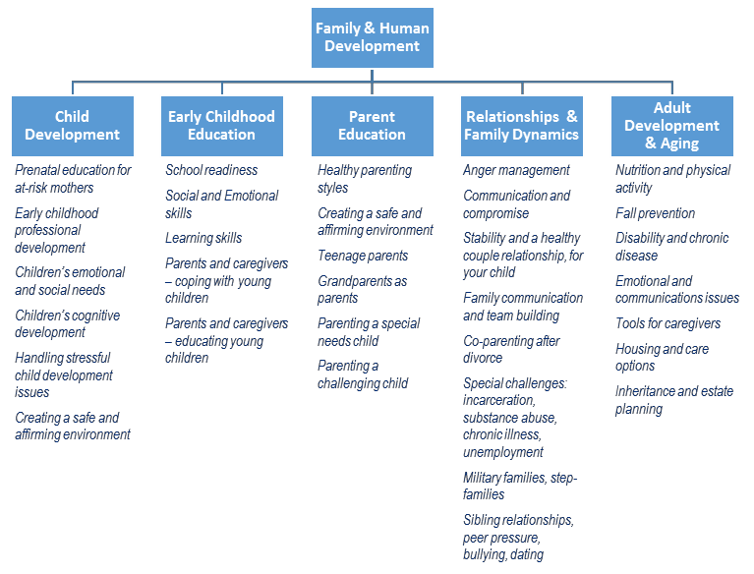

Using research to improve development and relationships across the lifespan is Extension’s central role within Family & Human Development, and Extension professionals in this area work on major questions and issues such as:
- What tools do expectant mothers need in order to make healthy nutrition decisions?
- What role does early care and education play in success in later stages of life?
- What are the most effective tools and programs for use in early care and education, and how can they be customized to specific community and family needs?
- How does parenting style influence a child’s development, and how can positive parenting be encouraged?
- What role do childcare providers play in a child’s development, and what is the best way of making them partners in healthy child development?
- What programming is needed for audiences with additional challenges, such as grandparents raising their grandchildren, single parents, stepparents, military families, etc.?
- How can individuals and families maintain healthy relationships and avoid destructive behavior?
- What are the unique needs and educational programming requirements associated with older adults and those engaged in their care?

Preventive programs that change behaviors and reduce negative outcomes can have profound impacts and cost savings for society. For example, Family & Consumer Sciences Extension programs targeting pregnant teens at risk for low birth-weight babies have been found to be successful in encouraging
expectant mothers to make healthier food choices and maintain a healthy pregnancy

Key finding: Family & Consumer Sciences Extension focuses on education and prevention, which is a key differentiating factor between it and social services agencies.
weight — both of which can directly reduce the incidence of low birth-weight babies. If such programs could reduce the incidence of low birth-weight babies across the nation by just 5 percent, research indicates that initial hospitalization stay savings would exceed
$278 million annually.12

Family & Consumer Sciences does not provide early childhood education, but rather works with those who do, to ensure that children have the best possible learning environments, experiences, and relationships in which to grow and learn. The extent to which Extension programs can influence behavior in a positive direction is illustrated by Rock Solid Foundations, a program to educate childcare professionals in creating environments that will enrich children’s social and emotional development.
Offered in many states across the nation, this program was developed at the University of Nebraska based on an earlier program from the Center on the Social Emotional Foundations for Early Learning.
More than 2,600 childcare professionals across the nation have been through the

Key finding: Family & Consumer Sciences Extension utilizes extensive train-the-trainer work to multiply the impact of its educational efforts.
course since 2011. Results from follow-up evaluations showed significant positive behavior change among participating childcare providers, affecting tens of thousands of children.

In the arenas of early childhood development and education, Extension provides a broad range of programming covering themes that include school readiness, early literacy skills, and the development of social and emotional skills. The majority of this programming targets parents and caregivers of preschool children, since they serve as primary role models for children and most
“We can gain money by investing early to close disparities and prevent achievement gaps, or we can continue to drive up deficit spending by paying to remediate disparities when they are harder and more expensive to close. The argument is very clear from an economic standpoint.”
James Heckman, Nobel Prizewinning economist from the University of Chicago, quoted in “The Two Year Window”,
New Republic Magazine, 2011
influence the environment in which children grow and learn. Programming in effective parenting practices is also an important focus, and because of their track record in offering effective, proven parent education, Family & Consumer Sciences Extension is frequently the resource that courts and state agencies turn to for delivering programming to parents who have been identified as needing more support and education. The Brooking Institution calculated that the effect of improving the parenting skills of parents with the poorest skills to the average level would lead to 9 percent
more of their children nationally graduating from high school, and 3 percent fewer of their children facing a criminal conviction by the age of 19.13

12 Agency for Healthcare Research and Quality, 2013, “Hospital Stays for Newborns, 2011”, Healthcare Cost and Utilization Project, www.hcup- us.ahrq.gov/reports/statbriefs/sb163.pdf
13 Reeves R and Howard K, 2013, “The Parenting Gap”, The Brookings Institution, Center on Children & Families, www.brookings.edu/research/papers/2013/09/09-parenting-gap-social-mobility-wellbeing-reeves

Family & Human Development also includes programs to strengthen families by helping people develop skills in communication and compromise, and giving both parents and children tools to help them better handle difficult developmental issues. Family & Consumer Sciences works with families to help all members better cope with challenges — such as a parent’s chronic illness, unemployment, substance abuse, or incarceration — and helps families navigate the impacts of family transitions such as
separation, divorce, deployment, stepfamilies, and incarceration. Failure to address these issues as they arise can increase the incidence of developmental and behavioral issues for the children.14

The aging of the population has the potential to become a major burden on the U.S. healthcare system. It is a strategic priority for the United States to improve the health of older adults, to fulfill the demand for caring and competent caregivers, and to enable older adults to live independently in their own homes longer. Family & Consumer Sciences Extension works with both older adults and the family, social, and community networks that surround them, with programming that ranges from retirement planning, to sustaining good health through nutrition and physical activity, to evaluating options for future living arrangements in the event of physical/mental decline, to working out inheritance plans and succession planning for family farms.

Key challenge: Insufficient resources are available to conduct comprehensive evaluations for the majority of programs, limiting the dissemination of FCS impacts.
Longitudinal tracking studies are the gold standard for measuring the effectiveness of initiatives and programming. Such studies have shown that the payoff to society from investments in human development initiatives and programming can be considerable. The two examples below serve to illustrate the

kinds of positive benefits that can be engendered through careful research on underlying needs, and research and development for best practice programs:

  - In one long-term study of a high-quality preschool program,15 results demonstrated societal savings (realized in areas such as reduced federal assistance or criminal justice costs) and societal benefits (such as higher taxes paid through increased earnings achievement) totaling $12.90 for every $1 spent on the program. Positive impacts from that controlled study of participants are still showing up more than 35 years later, and the study is still ongoing, showing that the benefits of high quality early childhood education last a lifetime.
- A major program developed at Iowa State University, the Strengthening Families Program: For Parents and Youth 10-14, which works to change behaviors associated with destructive actions such as alcohol and substance abuse, has been shown through a cost-benefit analysis to have economic returns of up to $9.60 for each $1 spent on the program.16

14 Vermont Department of Health, 2008, “Children in Families with Disabilities, HIV, or Chronic Illness”, healthvermont.gov/adap/clearinghouse/documents/J-Summary-Disabilities.pdf ; Wickrama K, Conger R, Lorenz F, & Jung T, 2008, “Family Antecedents and Consequences of Trajectories of Depressive Symptoms from Adolescence to Young Adulthood: A Life Course Investigation”, Journal of Health and Social Behavior, 2008 Dec 49(4) 468-483; Shaw D, Owens E, Giovannelli J & Winslow E, 2001,” Infant and toddler pathways leading to early externalizing disorders.” Journal of the American Academy of Child & Adolescent Psychiatry, 40, 36-43; Eddy J & Poehlmann J, 2010, Children of Incarcerated Parents. (J. M. Eddy & J. Poehlmann, Eds.). Washington, D.C.: Urban Institute Press
15 Schweinhar, L, Montie J, Xiang Z, Barnett W, Belfield C, & Nores M, 2005, “Lifetime effects: The HighScope Perry Preschool study through age 40”, Ypsilanti, MI: HighScope Press
16 Spoth R, Guyll M, and Day S, 2002, “Universal family-focused interventions in alcohol-use disorder prevention: cost-effectiveness and cost- benefit analyses of two interventions”, Journal of Studies on Alcohol, 2002 Mar;63(2):219-28.

Programing and Impacts in Family Resource Management

Family & Consumer Sciences Extension in this area is focused on helping families make the most of what they have on a daily basis, and helping those families who have the resources to use them wisely and plan financially for the future. It is clear that there is significant need for education in this area — studies have shown that 36% of Americans are worried about having enough money to pay their normal monthly
bills,17 a full 42% of parents who expect their children to continue their education after high school have
saved nothing at all for that, and 27% of workers report having $1,000 or less in retirement savings.18 Figure ES-4 shows the two high-level thematic areas of work in this domain, and key examples of content falling under these themes.

Figure ES-4: Principal areas of activity in Family Resource Management

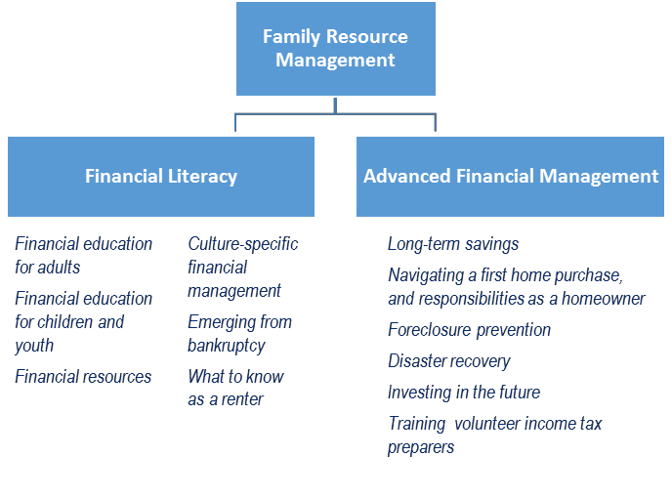

Family & Consumer Sciences Extension programming in Family Resource Management is effective on many levels. FCS Extension sets youth on a path of personal financial management capabilities, and program evaluations have shown that even elementary school students quickly learn about the link between education and earnings. High school students participating in programs including real-life simulations come away with an appreciation of not only how to budget and make spending decisions, but also an understanding of the costs of raising a child and the importance of waiting until they are financially able before starting a family. These innovative and engaging programs make a lasting impression on those making important decisions concerning continued education and careers. Programming in personal finance at this level can literally change the trajectory of a young person’s life.

17 Gallup's annual Economy and Personal Finance poll, conducted April 3-6, 2014
18 Princeton Survey Research Associates International, 2012, “2012 Household Financial Planning Survey”, prepared for Certified Financial Planner Board of Standards and the Consumer Federation of America, www.cfp.net/docs/news-events---research-facts- figures/2012_household_financial_planning_survey.pdf?sfvrsn=2

Programming for adults has its own rewards, as the results can often be seen immediately, when participants take basic steps like opening up checking and savings accounts and developing household budgets. Families may not be able to change their income level, but they can learn to make the most of what they have. In addition to being of immediate value to the family, the children will garner long-term benefits. Since parents are a child’s first and most important teachers, sound financial management modeled in the home means that more children will grow up absorbing healthy personal finance habits, resulting in more financial stability in the next generation.

Financial literacy involves a basic set of skills that almost anyone can learn, regardless of their income level, and which can improve the financial stability of participants and their families.

Reaching long-term goals may be more feasible once sound financial management becomes the standard in a home. FCS Extension programming educates families that have reached that first step to help them move on to setting aside money for emergencies, home ownership, and retirement.
Programming is also tailored for older adults who are preparing for their own particular important financial decisions concerning long-term care and estate planning.

Family & Consumer Sciences also provides direct education, and trains volunteers, to assist individuals with immediate financial problems and decision making. Senior Health Insurance Counseling, offered by Kansas State Extension, focuses on providing education to Medicare beneficiaries and was found to generate $20.69 in savings on medical and prescription costs for each $1 spent on the program in 2014. In Iowa, volunteers trained by Extension have completed over 10,000 income tax returns for low-income rural residents since 2008 as part of the Volunteer Income Tax Assistance program. This has resulted in $5.7 million in refundable earned income tax credits returned to Iowans.

Additional Programming Observations

As part of the research for this project, an inventory of program offerings was developed across states.
The inventory proved invaluable in understanding the breadth of programming available, but also
revealed instances of multiple states offering different programs with similar descriptions,

Key opportunity: Family & Consumer Sciences Extension in the North Central Region can strengthen its knowledge-sharing process to reduce parallel efforts and combine efforts in evaluation work in order to better document program successes.
goals, and target audiences. This inventory will provide a new basis for collaborative work within the region. The program leaders intend to use this as a guide to expand expertise, leverage existing programs, share evaluation efforts, and ultimately be more efficient in future program development.

Throughout the course of this evaluation, efforts to grasp the reach and effectiveness of Family & Consumer Sciences programming in the region were frustrated by the inconsistencies across states in reporting methods used, and in some cases the lack of useful data. Even a question as simple as “How many individuals directly received Family & Consumer Sciences Extension programming last year?” could not be answered by any state. States typically collect data on “direct contacts”, which duplicates the
count for those attending multi-session programs, and are usually unable to capture the number of unique individuals who participate in programming.

Key opportunity: Standardizing and strengthening basic reporting and evaluation methods will allow for more effective assessments and greater accountability. Understanding program effectiveness and grasping the extent of Family & Consumer Sciences Extension’s impact and reach are difficult because of a lack of consistent evaluation and reporting across programs and states.

Impact Reports, which are created for individual programs and are meant to convey the effectiveness of that program, come in every form and degree of detail, making it extremely difficult to compare programs across states, or aggregate data across the region.

Funding for Family & Consumer Sciences Extension

Family & Consumer Sciences Extension receives its funding through multiple sources, including: allocations from governmental agencies at the federal, state, and county levels; grants and contracts from governmental agencies, non-profits, and corporations; the sale of publications or curricula; and fees for delivery of programming. Figure ES-5 shows the breakdown of funding within the region.

Figure ES-5: Total Family & Consumer Sciences Extension funding by source within the North Central Region, 2014

Total 2014 Funding: $142.9 million

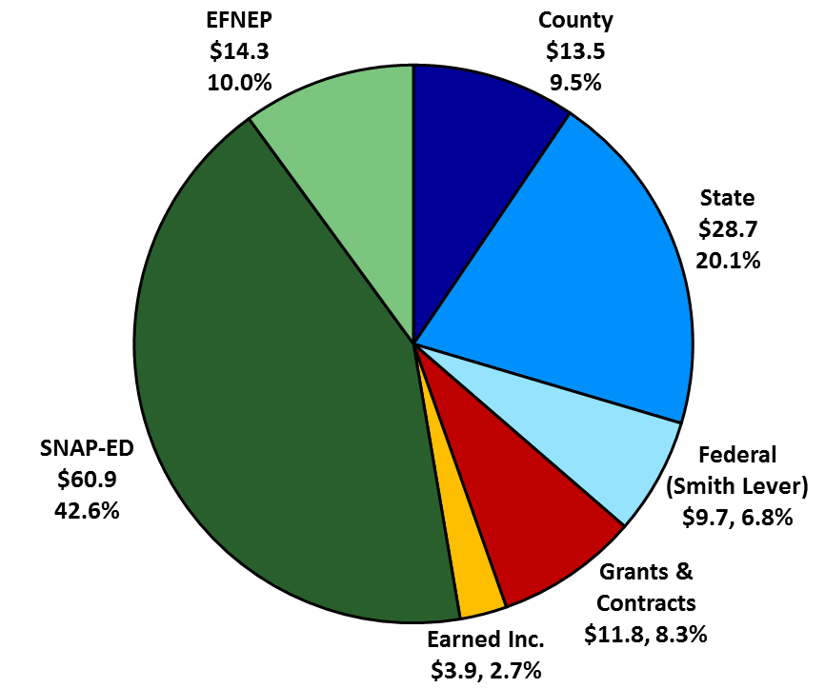

Three federal funding sources for FCS Extension — Smith-Lever, SNAP-Ed, and EFNEP — made up 59.4% of all FCS Extension funding in the region in 2014, and are all primarily formulaic. On its face, this situation would seem to ensure a steady, reliable base of funding on which FCS Extension could rely for continuity of programming and the development and realization of long-term goals within the discipline.
As this analysis has shown, however, neither Smith-Lever nor EFNEP have kept pace with inflation, and although SNAP-Ed has, the increase in SNAP-Ed funding has fallen far short of the increase in demand. The number of families receiving SNAP benefits has risen by 31% since 2010, while SNAP-Ed funding

has only increased by 6% in the same time period. The need for all Family & Consumer Sciences Extension services has grown, with continuing population growth, more people living in poverty, and increases in the rate of obesity, chronic disease, lack of savings, and other challenges to healthy living.

Key finding: Meeting a growing need for funding for Family & Consumer Sciences Extension in the North Central Region would result in the ability to support staff and additional programming that would help reach a larger percent of children, youth, and families in need of education.
In addition to systemic problems with ensuring adequate funding for key programs, the sequestration cuts in the middle of 2013 significantly reduced total funding for the year for these three programs, which required drastic reduction and elimination of scheduled programming for the balance of the year, since the cuts were made when the year was already well underway.

There is also significant variation in the levels of funding across the states, in total and per capita, with the three largest states being at a significant disadvantage, with among the lowest funding totals (excluding SNAP-Ed and EFNEP).

A more stable and even base of funding over time would help to assure improved access to FCS Extension programming for communities, families, and individuals, as well as the organizations that support and collaborate with them.

Moving into the Future

Family & Consumer Sciences Extension in the North Central Region is ideally positioned to be an important contributor to Health Extension, the National Framework for Health and Wellness which was unveiled in 2014 by the Extension Committee on Organization & Policy (ECOP). This new programmatic focus will tap into the substantial competencies of Family & Consumer Sciences Extension regarding nutrition and health issues, which are illustrated in this report, and particularly leverage Extension’s established and robust education delivery capabilities, which potentially reach into every community in the country either directly or through partnerships with a broad variety of other organizations. Health Extension will form a new emphasis focused on improving the nation’s health. Still awaiting funding, the new initiative represents a vision for America:
“The Extension model arose at a time when American agriculture was largely inefficient and only marginally productive. The consequences of the agricultural practices of the time were endangering our nation’s economic, environmental, and personal health. A century later, American agriculture is without equal in its contributing food to a growing world population. We, and others, believe that this same system of Extension can do for the nation’s health what it did for American agriculture.”

Excerpt from “Cooperative Extension’s National Framework for Health and Wellness”, 2014, on the 100th anniversary of the signing of the Smith-Lever Act, which created the nation’s Cooperative Extension System.

In Conclusion

Battelle’s review of Family & Consumer Sciences Extension in the North Central Region reveals a highly dynamic, pragmatic, and contemporary applied academic discipline that is making a positive difference in the lives of millions of Americans, and, by extension, enriching the communities in which they live, and the nation as a whole. Family & Consumer Sciences Extension addresses some of the most pressing social challenges facing the nation, its communities, and its families through research-based educational programming. The Extension system is unique in its capacity to reach broad swaths of the American public, in every state and county, with consistent, research-based programming.

Today, a major factor limiting the prospects for America’s future is the diminished health and well-being of its citizens compared to previous generations. Family & Consumer Sciences Extension, through its strong research capabilities and its effective, state-wide education delivery system, helps to address those issues with educational programming across the lifespan, across all socio-economic classes, in rural and urban settings, and through both traditional and innovative avenues. Through extensive partnerships with public and non-profit groups across the nation, it works to leverage resources and reduce duplication of effort across multiple entities working toward the same purpose. As a provider of proven educational materials and programming, it is a go-to source for many of those same entities, and can be seen to form the bedrock or foundation that supports the activities of a large network of individual organizations, family serving agencies, educators, and other stakeholders that provide education and support for individuals and their families.

Family & Consumer Sciences Extension in the North Central Region also works to establish the structure and create the processes to ensure that more people can be encouraged to make positive, healthy choices, and has become involved in policy discussions at the local, state, and national levels to help to affect broad societal changes that will increase the well-being of all.

Within the North Central Region, many differences were uncovered among the twelve states in the region, reflecting different organizational structures, programming emphases, reporting practices, funding sources, and many other details. These differences, however, are dwarfed by the common mission of improving the health and well-being of the people in their states and in the country, and the power and effectiveness of the programming offered. Particularly noteworthy is the high level of continued innovation and optimism, even in the face of budgetary constraints that are in some cases extreme.

The educational activities of Family & Consumer Sciences Extension in the North Central Region is profiled in the full report, along with published research evaluations. They serve to illustrate an academic discipline that is efficient and cost-effective in delivering programs that not only improve American lives and the strength of our nation, but also provide long-term cost savings. Although this report evaluated Family & Consumer Sciences Extension in the North Central Region, many of the findings in it will be applicable Family & Consumer Sciences Extension across the country.

