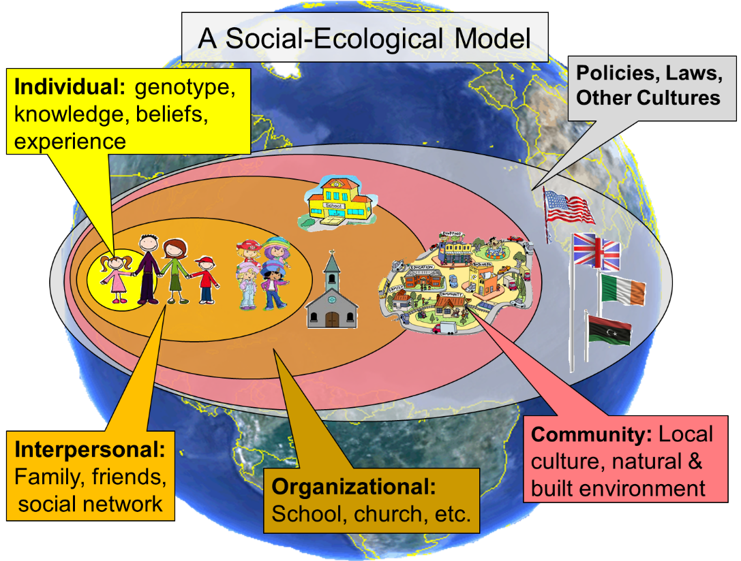
The Social-Ecological Model forms the theoretical basis for FCS Extension Education. This theory posits that individuals develop within the contexts of family, communities, and society; and their developmental outcomes whether poor or positive are influenced as they interact with these various systems. We view families as active participants in the social-ecological system. They make decisions, exchange resources, and examine costs and benefits of alternatives given their current situation. Families also take steps to change their environment to better support their development.
Nickols, S. Y. (2003). Human Eco-System Theory: A Tool for Working with Families. Journal of Family and Consumer Sciences, 95, pp. 15-19.
Tudge, J.R.H., Mokrova, I., Hatfield, B.E., and Karnik, R. B. (2009). Uses and misuses of Bronfenbrenner’s Bioecological Theory of Human Development. Journal of Family Theory & Review, 1(4), pp. 198-210.

Results of 2015 Battelle Study: Analysis of the Value of Family and Consumer Sciences Extension in the North Central Region

Key Findings

Family and Consumer Sciences Extension Programming:
- Results in substantial economic returns to the nation.
- Makes a positive difference at the community level by putting into place infrastructure that facilitates positive behaviors, and helps shape policy at the local, state, and national levels.
- Utilizes the most effective educational materials available, regardless of where they were developed.
- Partners with other agencies and non-profits to leverage resources and reach people as effectively as possible.
- Focuses on education and prevention which is a key differentiating factor between it and social services agencies.
- Utilizes extensive train-the-trainer work to multiply the impact of its educational efforts.

Meeting a growing need for funding for Family & Consumer Sciences Extension would result in the ability to support staff and additional programming that would help reach a larger percent of children, youth and families in need of life stabilizing education.

Economic Impacts of FCS Programming
- A review of research literature revealed that every $1.00 spent on EFNEP results in savings in food expenditures of $2.48 and savings of anywhere from $3.63 to $10.75 in future healthcare costs. As a result, long-term cost savings to the North Central Region based on 2014 participation in EFNEP can be estimated at $86–$185 million. (Potential savings in Kansas is estimated to be $4 to $9.4 million.) SNAP-Ed is a significantly larger program, and had 728,000 participants in the North Central region in 2014. Cost savings estimated at even half the level of the most conservative scenario for EFNEP would be at least $185 million each year. (In Kansas, $27 million per year.)
- The Chronic Disease Self-Management Program, developed at Stanford University (and called Kansans Optimizing Health Program or KOHP in Kansas), provides an approximate $4.00 savings in health care expenditures for every $1.00 spent on the program.
- Family & Consumer Sciences Extension partners with the National Restaurant Association to provide ServSafe® education which can reduce foodborne illness and savings in associated healthcare costs and losses annually.
- Senior Health Insurance Counseling to provide education to Medicare beneficiaries resulted in $20.69 in savings on medical and prescription costs for each $1.00 spent on the program in 2014.

“We can gain money by investing early to close disparities and prevent achievement gaps, or we can continue to drive up deficit spending by paying to remediate disparities when they are harder and more expensive to close. The argument is very clear from an economic standpoint.”
James Heckman, Nobel Prizewinning economist from the University of Chicago, quoted in “The Two Year Window”, New Republic Magazine, 2011

