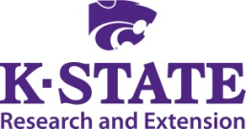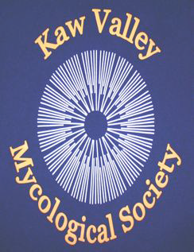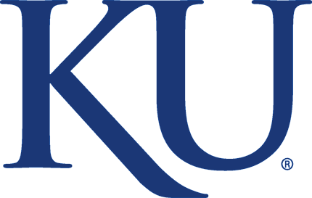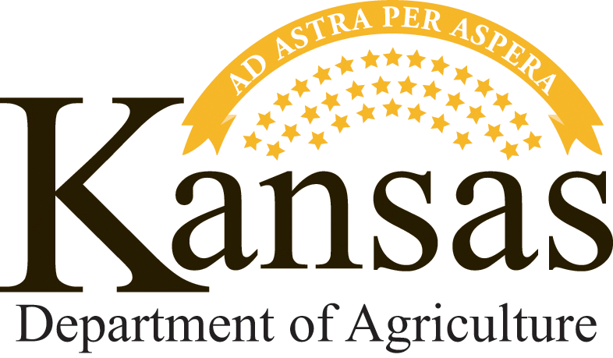
Morel Mushroom Certification Workshop

Friday, March 4, 2016; 4PM- 6PM

Held at: Douglas County Fair Grounds- Dreher 4-H building
2110 Harper Street
Lawrence, Kansas 66046

This workshop is intended to help assure that wild harvested mushrooms sold as morels in the state are actually morels and safe to consume. The current Kansas Department of Agriculture (KDA) Food Safety and Lodging regulations state that mushrooms picked in the wild for sale must be individually inspected for safety by an approved mushroom identification expert. Those successfully completing this workshop will be recognized as morel identification experts for the purposes of meeting this regulation. Note that these regulations and this certification do NOT apply to cultivated mushrooms, such as shiitakes, but only to mushrooms harvested in the wild. Cultivated mushrooms do NOT require an identification course.

The course will be taught by mushroom identification expert Sherry Kay from the Kaw Valley Mycological Society. There is no charge for the course this year.
The workshop will cover the following:
- Background on the regulation and certification requirements
- Pre-training identification test
- PowerPoint presentation on distinguishing morels from false morels and other non-edible varieties of wild mushrooms
- Post-training identification test for certification (and re-testing as needed)

Morel Mushroom certification
After successful completion of the workshop and test, participants will need to sign a liability waiver and can then receive wall-size and wallet-size training certificates recognizing them as an “approved morel identification expert.” The certification is currently a three year certification. If you cannot attend the course this year but would still like to register your mushroom identification qualifications, you will have until August 2016 to register your qualifications by other means.

Registration:
Pre-registration for the workshop is required. Participants can register online at: http://agriculture.ks.gov/mushroom-identification-workshop or complete the form on the reverse side (one form for each participant) and mail as indicated. There is no charge for the course this year. The class will be limited to the first 90 people that sign up, with first preference given to people from Kansas harvesting mushrooms in Kansas. Any additional spaces available after February 26 will be opened to people from outside of Kansas. You will be notified of your registration status.

Registration form
Participants can register online at: http://agriculture.ks.gov/mushroom-identification-workshop or complete the form below (one form for each participant) and mail it to:
Kansas Department of Agriculture
Wild Mushroom Identification Workshop
1320 Research Park Drive
Manhattan, KS 66502

Name:

Mailing Address:

City, State, Zip Code:

Phone: Email:

Mushroom identification qualifications (other certification, etc.)/years of mushroom hunting experience:

For more information, contact:
Londa Nwadike, KSU/MU Extension Food Safety Specialist
22201 W. Innovation Dr., Olathe, KS 66061
Tel: 913-307-7391
Email: lnwadike@ksu.edu

This workshop is organized by Kansas State University Research and Extension, Kansas State University Biology Department, the Kaw Valley Mycological Society, The University of Kansas Biological Survey, and the Kansas Department of Agriculture Food Safety and Lodging Program.

KSRE is committed to making its services, activities and programs accessible to all participants. If you have special requirements due to physical, visual, or hearing disability, please contact Londa Nwadike at lnwadike@ksu.edu

Kansas State University Agricultural Experiment Station and Cooperative Extension Service

K-State Research and Extension is an equal opportunity provider and employer. Issued in furtherance of Cooperative Extension Work, Acts of May 8 and June 30, 1914, as amended. Kansas State University, County Extension Councils, Extension Districts, and United States Department of Agriculture Cooperating, John D. Floros, Director.

