

**Water Sampling Procedure**

1. Label collection bottle with your name, phone number, sample identity (i.e. west well, north pond, etc), whether the sample is surface or ground water and the date that was collected.
2. Wash hands thoroughly with soap and warm water. Gloves are not required.
3. If using water sampling stick, place provided water sample bottle onto it.
4. Remove the lid from the container with care to not touch the inside of the container or lid. **Do not rinse the sample container.** There will be a white powder in each bottle to counteract any chlorine that may be present in the water for testing purposes.
5. For a surface water source, dip the sample bottle down to a depth of 6-12 inches. If water is static, create a current by moving the sample bottle horizontally away from your body under water (see image below)
6. Move the top of the bottle slightly upward to allow air to exit.
7. For well water, run the pump for a few minutes to make sure the water in well riser is not sampled. Make sure the sample represents the current well water.
8. Fill the water a little past the 100mL fill line on the bottle.
9. Cap the sample container, again with care to not touch the inside of the lid or container.
10. Ensure that the labeling remained on the bottle, as described above.
11. Place the sample bottle inside a sealable plastic bag and store in a cooler (<50F), but do NOT freeze the samples until time of mailing or delivering the samples to the laboratory.
12. Mail the samples on ice within 24 hours.

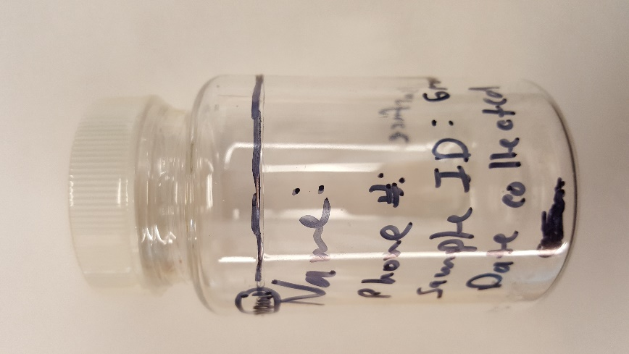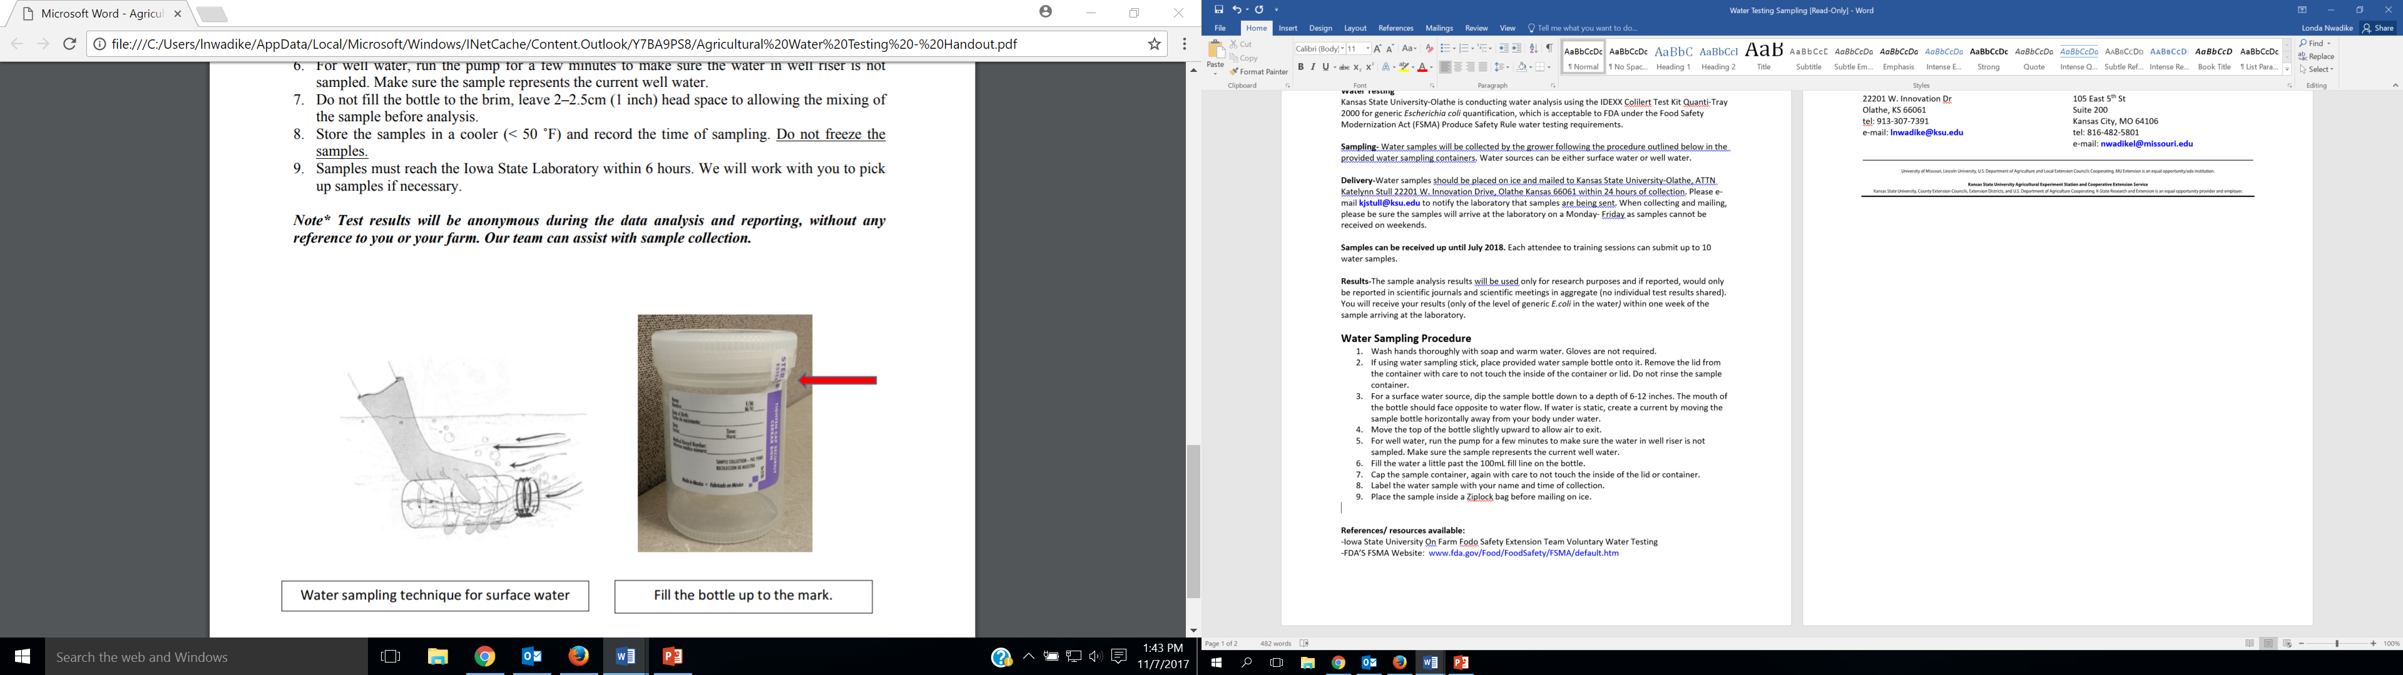

Fill bottle to line and label as described.

Water sampling technique for still surface water.

