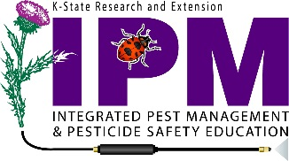 2023 Kansas Paraquat Training Information
Frequently Asked Questions
So do all paraquat dichloride product labels require the additional training?
All products featuring the new labeling with the active ingredient paraquat dichloride, such as Gramoxone, Firestorm, Helmquat and Parazone will require the additional training in order to apply these products. Remember if the new training requirement is listed on the label of the product you are using, then you MUST complete the training.
Who is required to take this training?
Any person who intends to use paraquat must be a certified applicator and is required to take this training.
How often am I required to receive the training?
The training is required every three years. Check to make sure your training is current!
Do I need to be certified to use products containing paraquat dichloride?
The newly labeled products state that “Product may ONLY be mixed, loaded or applied by a certified applicator who has successfully completed the paraquat-specific training before use. Application “under direct supervision” of a certified applicator is NO LONGER allowed. In the state of Kansas, this means that everyone purchasing and using these products has to either obtain a private applicator license (application to agricultural lands owned or operated by individual) or a commercial applicator license (applicators applying to other people’s land for compensation). If you have been applying under someone else’s license in the past you will need to get your own license before applying these products.

How can I complete the training requirements?

The only training that meets the requirements is housed on the eXtension website and can be found by going to: http://usparaquattraining.com. If you don’t currently have an account you will need to create one before it will allow you to take the training. For in-person training materials, please visit https://npsec.us/paraquat

This information is made available by the K-State Pesticide Safety and IPM Program. Contact your local Extension Office if you need any additional information.

