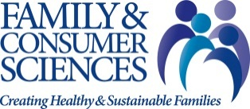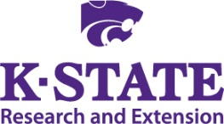
Essential Living Skills

K-State Research and Extension Family and Consumer Sciences programs transform lives through linking research and evidence based education with life experiences to help people improve their lives, their families, and their communities. Personal, family and community well being is dependent upon many kinds of knowledge and skills which are intertwined and inseparable. We provide a broad base of expertise to help solve complicated problems by teaching these essential living skills.

Healthy Relationships

Family and Consumer Sciences Extension promotes healthy relationships, the foundation of all human interaction. Effective communication, respect for differences, making sound decisions and managing life challenges are all pivotal in establishing strong individuals, families and partnerships.

Healthy Living Choices

Living healthfully is about feeling and being well physically, emotionally, and socially. Family and Consumer Sciences Extension educates and supports individuals, families and communities to make healthy choices around active living, nutritious eating, preventing and managing chronic illness, balancing work and life, and being responsible for the environment.

Financial Well Being

Family and Consumer Sciences Extension helps individuals and families become financially stable. Managing their financial resources to be able to secure adequate food, clothing and shelter as well as make informed consumer choices with credit, saving and spending helps increase financial security for the individual, their family and their community.

Strong Leaders

Family and Consumer Sciences Extension helps transform lives and build healthy communities by developing leaders. Leadership skills expand the capacity of individuals to excel to be their best at home, at work and in their community. Development of strong interpersonal communication skills, networking, responsible decision-making and team building helps to empower individuals to thrive in an ever-changing society.

Strong Communities

Family and Consumer Sciences Extension strengthens communities by reaching people of varying cultural and socioeconomic backgrounds with education to help improve and optimize the most basic aspects of life such as food, shelter, clothing, safety, health and relationships as well as quality of life, financial security, citizenship and engagement with community organizations and events.

