



Water Testing Information- Missouri Produce Growers

Water Testing- University of Missouri (MU) Extension is offering free water testing to produce (fruit, vegetable and herb) growers in Missouri through a USDA National Institute of Food and Agriculture (NIFA) grant. Testing for Missouri producers will be conducted by the Missouri Department of Health and Senior Services (MDHSS) laboratory in Jefferson City, MO, using the IDEXX Colilert Test Kit Quanti-Tray 2000 for generic Escherichia coli quantification, which is one of the methods that is acceptable to FDA under the Food Safety Modernization Act (FSMA) Produce Safety Rule water testing requirements. These results will also be accepted by USDA GAP auditors and possibly other GAPs auditors. Note that this free testing program will last until at least Dec 31, 2020.

Produce Growers must utilize water sample bottles provided by your local health department laboratory, MDHSS, or the Missouri Department of Agriculture (MDA) or University of Missouri Extension produce safety teams and must follow the instructions below to collect water samples. Water sources can be surface water or ground (well) water.

Sample Transport Instructions:
Samples must be received by the MDHSS lab and tested within at least 48 hours (ideally 24 hours) of the date and time of collection. The MDHSS lab recommends that you use the free DHSS contract courier for overnight delivery to the lab in Jefferson City. This courier picks up at most local public health agency offices (Monday-Thursday). For sample drop off locations and times, please go to https://health.mo.gov/lab/courierservices.php or you may call the MDHSS lab courier liaison at (573) 751-4830. Samples should not be en route to the laboratory over a weekend or state holiday. Be sure to overnight your sample and ship it on ice if using a commercial carrier.

Results- You will receive your results (the level of generic E.coli in the water and total coliform count) within approximately one week of the sample arriving at the laboratory. The sample analysis results will also be shared with MU Extension and MDA only for research and educational purposes, but will not be shared or used in other ways.

Water Sampling Procedure
- Complete the MDHSS lab Bacteriology Private Well Water Test Request form which is included in water sample kits available from local public health agencies or from: https://health.mo.gov/lab/pdf/lab-177-private-water.pdf To ensure that you get the correct test result and do not need to pay for the water testing, in the “Test Requested” section at the top of the form, please mark “other” and write in “MPN for produce”. Also mark “no charge routine well” in the “Test Requested” section. In the “No Charge Justification” section at the bottom of the form, mark “USDA/Non USDA inspected facility” to ensure that you do not need to pay for the test. For surface water samples, in the “construction type” section of the form, mark “other” and list the type of surface water (e.g. “pond”).
- Label collection bottle with your name, sample identity (i.e. west well, north pond, etc), and the date that was collected.
- Wash hands thoroughly with soap and warm water. Gloves are not required but are a good practice.
- If using water sampling stick for surface water (such as a pond), affix provided water sample bottle onto it.
- Remove the lid from the container with care to not touch the inside of the container or lid. Do not rinse the sample container. There will be a white powder in each bottle which is needed for testing purposes.
- For a surface water source, dip the sample bottle down to a depth of 6-12 inches. If water is static, create a current by moving the sample bottle horizontally away from your body under water as shown in the image below.
- Move the top of the bottle slightly upward to allow air to exit.
- For well water, run the pump for a few minutes to make sure the water in the well riser is not sampled. Make sure the sample represents the current well water.
- Fill the water a little past the 100mL fill line on the bottle.
- Cap the sample container, again with care to not touch the inside of the lid or container.
- Ensure that the labeling remained on the bottle, as described above.
- Place the sample bottle inside a sealable plastic bag and store in a cooler (<50F), but do NOT freeze the samples.
- Transport the samples as described above so that they will arrive at the lab within 48 or ideally 24 hours of sampling.
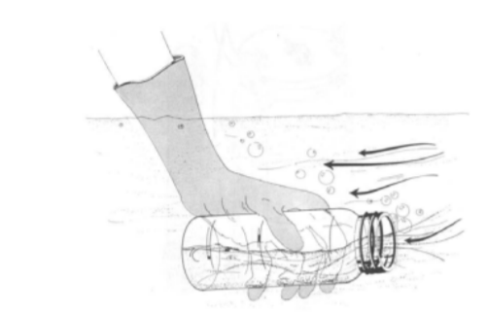
Water sampling technique for still surface water.

For more information on produce safety and water testing, please visit the Kansas State University/University of Missouri Extension Produce Safety website: www.ksre.k-state.edu/foodsafety/produce/
Testing funded by USDA NIFA grant 2019-70020-30358

For produce safety information, please contact Dr. Londa Nwadike:
105 East 5th St
Suite 200
Kansas City, MO 64106
tel: 816-482-5801
e-mail: nwadikel@missouri.edu

