Client & Product Information
When possible, please use MS Word to provide us an electronic copy of this form by email (KVAFL@KSU.EDU). When sending your product to the lab for testing, please include a hard copy of this form with your product.

Name Date

Company

Address

City State Zip

Phone (work) (home)

E-mail

Product(s) #1: Container Size(s)/Type #1:

#2: #2:

#3: #3:

Container Lid Type:

Testing Needed: (mark all that apply)
Prices reflected are: (Kansas Clients/Out-of-State Clients)

Process Authority Letter & Nutrition Label Combo ($150/$300 per letter; pay up front). Multiple products or formulations will require separate Process Authority letters.

Process Authority Review Letter ($100/$200; pay up front)

Nutrition Labels ($100/$200; pay up front) PLEASE NOTE: All nutrition labels are generated using nutritional information from a database. Our lab does not have the capability to run full nutritional analysis on food products.

Shelf Life Study (Product Dependent; will be invoiced after testing)

Microbial Testing (Product Dependent; will be invoiced after testing): check all that apply.
Aerobic Plate Count Yeast & Mold Coliforms (E. coli)

Individual Tests (check one or more)
pH ($15/$30) Moisture Content ($50/$100)
Water Activity (Aw) ($15/$30) Gluten Testing ($100/$200)
Sodium Content ($15/$30) Instrumental Color Evaluation ($100/$200)
Brix ($15/$30)
Other: ______________________(call for pricing)
Please provide the ingredients for your product in the table below (feel free to extend the table to accommodate all of your ingredients). PLEASE TYPE THIS INFORMATION, DO NOT HAND WRITE. THANKS!
Formula Sheet**
Specific Ingredient  (e.g. Heinz Ketchup)  Include specific brand names with ingredient descriptions | Ingredient Weight or Volume ONLY (e.g., grams, fluid ounces, milliliters)  Do not provide household measurements, e.g. teaspoons. | Ingredient Components  (Include all ingredient components, e.g., tomato concentrate from red ripe tomatoes, distilled vinegar, high fructose corn syrup, frozen, fresh or canned ingredient)
**Providing details, such as the brand name, spec sheets, nutrition profiles, and nutrition facts panels for each ingredient expedites the generation of your Nutrition Facts Panel. Use more than one sheet, if necessary, or provide other documentation. We will contact you if we need additional information. You may be asked to contact your ingredient supplier to provide additional nutritional information for label accuracy.

FOOD PROCESS DESCRIPTION
PROVIDE A DETAILED DESCRIPTION OF YOUR PROCESS—INCLUDING TEMPERATURE AND TIME INFORMATION, AND THE TYPE OF RETAIL CONTAINER FOR THE PRODUCT. Include all processing parameters such as temperature, holding time, inverting the container after filling, etc. If the container is plastic, indicate the maximum temperature the plastic can withstand. Please use as many pages as necessary to provide us with a thorough description of your food product process.

For clients requesting a Nutrition Label, please select the following label format needed for your label.*
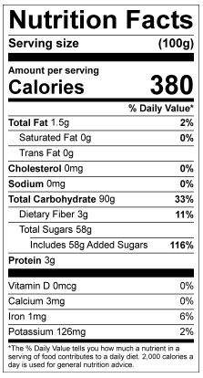
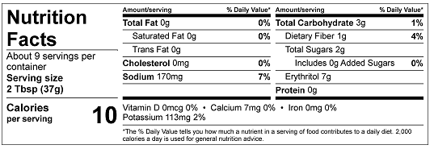
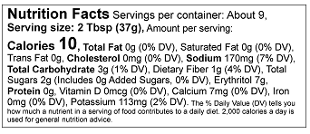

Tabular Label

Linear Label

Standard Label

*Some products may require a dual column label, which will be communicated to you once it has been determined. This is done at no additional charge.
Some labels may qualify for simplified labeling for no additional cost.
Please refer to “Food Labeling for Kansas Food Producers and Processors – MF3385” on our website (ksre.ksu.edu/kvafl) for more information on nutrition labeling. Label format will depend on label size.

General Information and Next Steps:
Please be aware that your company is solely responsible for the content and accuracy of your labeling and Kansas State University assumes no liability for your use of the nutrition facts labels. By submitting this application and engaging us to calculate the labels, you expressly agree to hold harmless and indemnify Kansas State University, the State of Kansas, the Kansas Board of Regents, and all their agents, officers, and employees, from all claims, demands, and causes of action of any kind that may arise as a result of its performance of these activities.

Confidentiality Notice: All formulas, concepts, ideas, and/or other intellectual property of KVAFL clients shall remain confidential, and will not be used by KVAFL employees, or other Kansas State University students, for personal gain unless agreed upon by both parties.

Once finished with this paperwork, email a copy to kvafl@ksu.edu for the team to review BEFORE YOU SEND YOUR PRODUCT so we can ensure that we have all the information we need.

KEEP COPIES OF ALL SUBMITTED PAPERWORK FOR YOUR REFERENCE!

