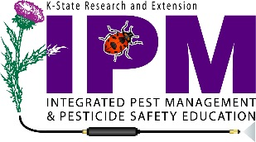
2023 Kansas Dicamba Training Information

Frequently Asked Questions

Do all dicamba product labels require the additional training?
You are required to have additional label-required dicamba training when applying the restricted use dicamba products: Engenia, XtendiMax or Tavium with Vaporgrip.
Where can I get the training for 2023?
BASF: (webinars, online training and face to face) engeniaherbicide.com/training.html
Bayer/Monsanto: (online training and face-to-face) https://www.roundupreadyxtend.com/stewardship/Pages/default.aspx
Syngenta: https://www.syngenta-us.com/herbicides/tavium-application-stewardship

Do I need to attend training if I already did in 2021 or 2022?
The labels of these products state that prior to applying this product in the 2023 growing season, all applicators must complete dicamba or auxin-specific training on an annual basis, so even if you attended in 2021 or 2022 you will need to attend a training in 2023 prior to applying these products.

Do I need to be certified to use these products?
The new labels state that these formulations are for retail sale to and use only by certified applicators. In the state of Kansas, this means that everyone purchasing and using these products has to either obtain a private applicator license (application to agricultural lands owned or operated by individual) or a commercial applicator license (applicators applying to other people’s land for compensation). If you have been applying under someone else’s license in the past you will need to get your own license if you are applying these products.

My hired hand and I both hold private applicators licenses. He will be doing all my spraying. I am taking the dicamba training, but does he also have to take the dicamba training?
Yes, anyone who applies one of the RUP dicamba products must complete an approved dicamba training and hold either a private or commercial applicator license.

Do other states accept Kansas’s state-approved RUP dicamba training?
Oklahoma does not accept online or live webinar dicamba training provided by BASF. Colorado, Missouri and Nebraska will accept training offered by Bayer, BASF and Syngenta.

This information is made available by the K-State Pesticide Safety and IPM Program. Contact your local Extension Office if you need additional information.

Updated: 1/5/23

